

**School of Computing**

**SRM IST, Kattankulathur – 603 203**

**Course Code: 18CSC206J**

**Course Name: Software Engineering and Project Management**

| **Experiment No** | 13 |
| --- | --- |
| **Title of Experiment** | Provide the details of ArchitectureDesign/Framework/Implementation |
| **Name of the candidate** | [Alankriti Dadlani](mailto:alankriti.dadlani22@gmail.com) |
| **Team Members** | **ARITRA KARAR (RA2111028010019)**  [SANJAY P (RA2111028010012)](mailto:sm8353@srmist.edu.in) |
| **Register Numbers** | **RA2111028010010** |
| **Date of Experiment** | **28.04.2023** |

**Mark Split-up**

| **S. No** | **Description** | **Maximum Mark** | **Mark Obtained** |
| --- | --- | --- | --- |
| 1 | Exercise | 5 |  |
| 2 | Viva | 5 |  |
| **Total** | | **10** |  |

**Staff Signature with Date:**

**Aim:**

To provide the details of architectural design/framework/implementation

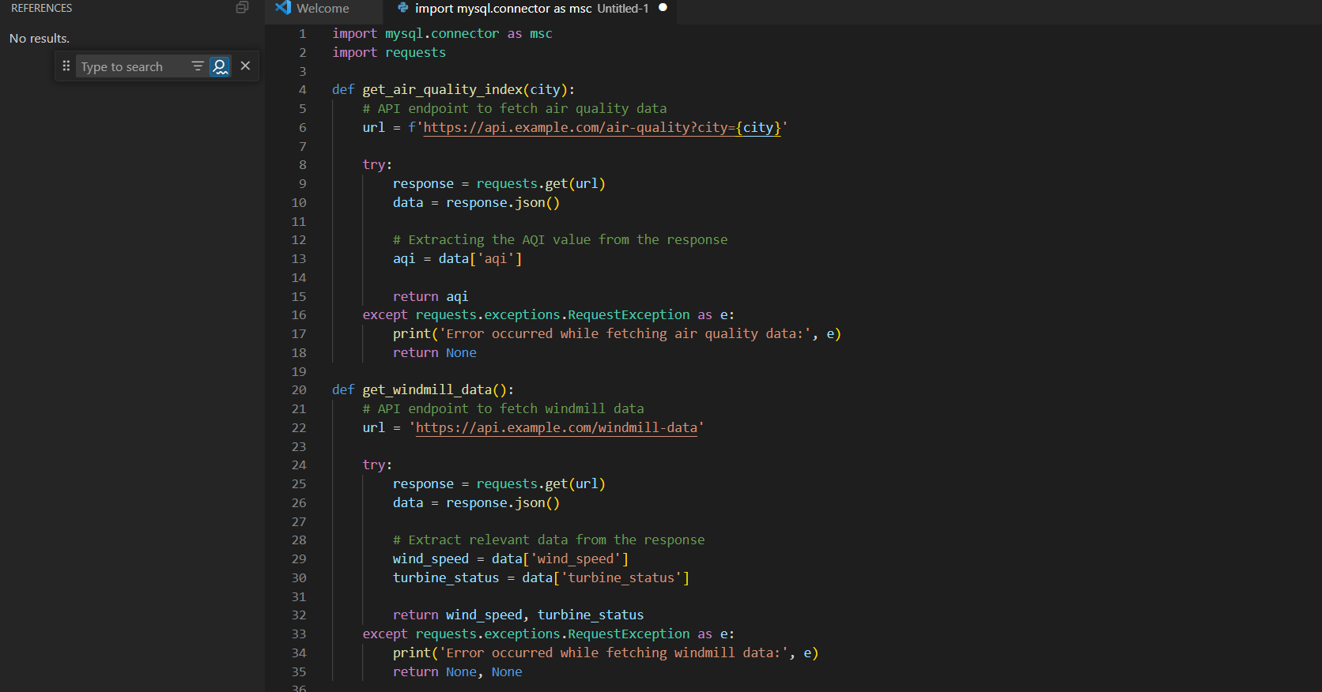

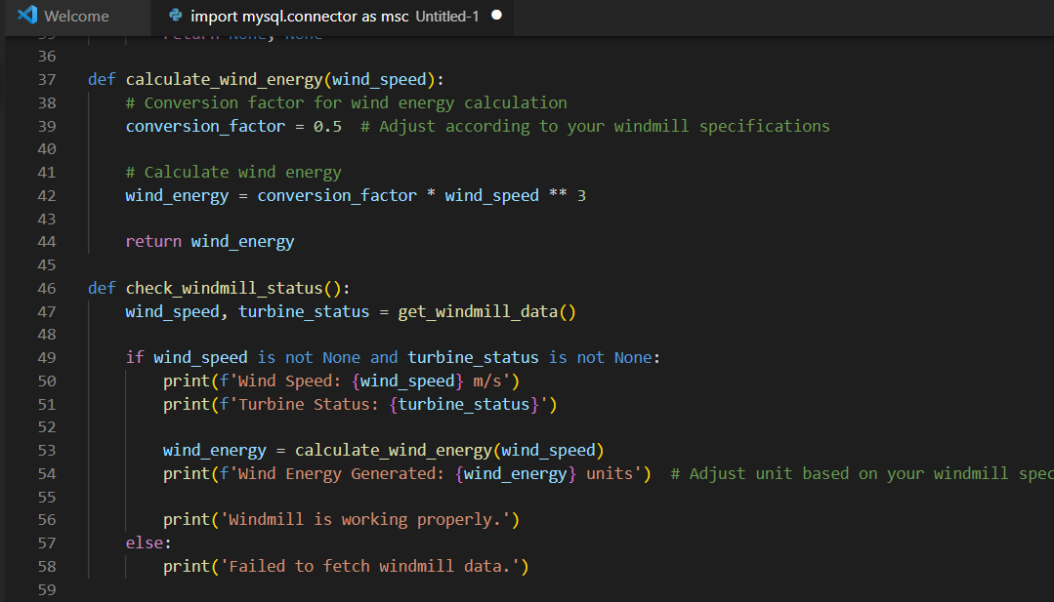

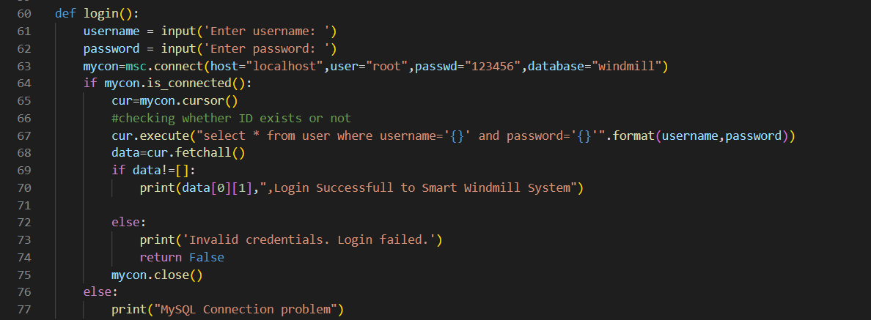

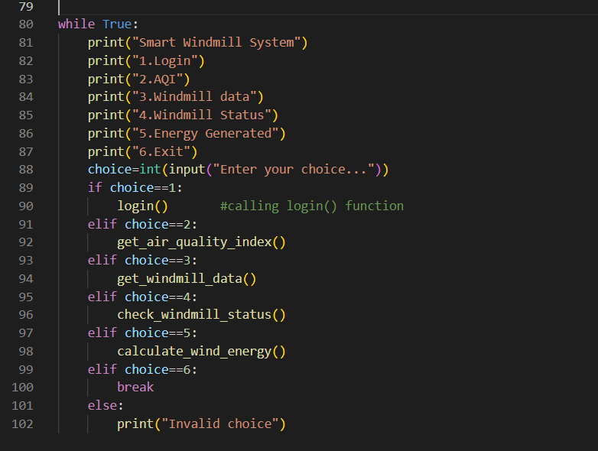

User Database:

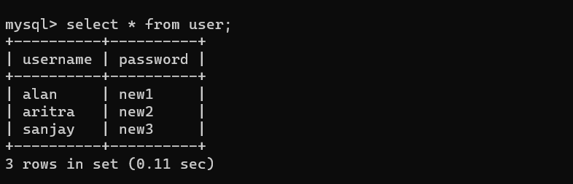 Output:

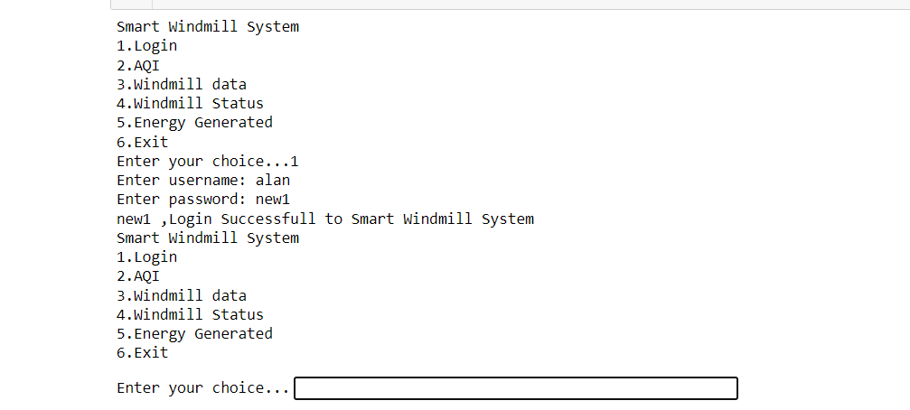

Result:

Thus, the details of architectural design/framework/implementation along with the screenshots were provided.